Spatial Layout Authoring
  - No-code experience for laying out a physical environment as ontology, data, and entity geometry

Objective
Most businesses that could benefit from spatial intelligence have no 3D models of their environments, and that absence is a major barrier to adoption. Spatial Layout, a new Fabric item, removes it: a customer can lay out a single physical environment (e.g., a warehouse, a factory, a substation) by placing entity instances in a 3D space, with no code, no separate application, and no hand-authored USD, and the result is live, governed, and renderable in the Physical Space item.
Customers sit on a spectrum. At one end are those with no 3D models, who start from placeholder geometry in the SimReady asset library. At the other are those with high-fidelity models, built in-house, supplied by manufacturers, or commissioned from vendors, often exported from CAD and BIM tools. Spatial Layout serves the lower end of the spectrum and lets customers move along it over time, raising fidelity asset by asset as needs and budget allow.
Time to first value is a key goal. The aim is a 5x5 experience, where a new user gets a working spatial view in minutes, not days. Placeholder geometry and the no-code canvas produce a useful result quickly, with fidelity and breadth following at the customer's pace. Spatial Layout is the top of the funnel for spatial intelligence on Fabric: it is where customers start, and the low barrier to entry is what makes product-led growth possible. It is also a strong sales tool for the field.
Spatial Layout is most useful for static assets such as shelves, racks, walls, and fixed equipment, whose position is authored once and rarely changes. Moving assets such as forklifts and pallets take their position from live data, so Spatial Layout gives them a placeholder and leaves the live connection to other items.

Approach
Spatial Layout produces ontology, data, and entity geometry. The 3D scene the user interactively works in is composed on demand from those and discarded when the session ends, so authoring leaves no saved monolithic scene and no second source of truth to keep in sync.
Reading through an ontology binding is safe, because the binding names the columns to read. Writing back through it is not. An insert must satisfy the whole table contract, including required columns and constraints that a binding never captures, so writing into arbitrary customer schemas is fragile. Spatial Layout therefore generates its own ontology, tables, and USD assets: every table it writes is one it creates and owns.
What it generates is narrow. An entity type has a geometry property pointing at a USD asset, set as a default on the type so identical instances share one mesh, with an optional per-instance table binding for overrides. A containment relationship type connects two entity types and carries position and orientation relative to the parent. Property values are bound to tables, and the USD assets hold the geometry. The scope is static spatial layout: where things sit and what they look like. Every canvas action edits this ontology, its tables, and its USD assets, which is then re-composed into an updated scene.
The other ontologies bring what the spatial layout lacks. The enterprise ontology, specific to the business operating the environment, carries the meaning and live state of the same entities: their business properties, relationships, and telemetry, bound to the business's own systems and data. A manufacturer's ontology defines the entities, properties, and relationships of a physical asset and its components, with no notion of where it sits in a warehouse or factory.
The layout could be defined in the enterprise ontology directly, or a business starting fresh could adopt Spatial Layout's output as that ontology. But spatial values are far easier to author and preview visually, and it is cleaner to keep the layout as its own ontology and compose it with the others. This design assumes ontology composition, which is on Fabric’s roadmap. Under composition, entities are matched across ontologies by shared identity, so one defined in several carries the properties of all. Nothing is copied or rewritten, each ontology stays with its owner, and Spatial Layout writes only its own.
Spatial Layout's narrow scope also marks where it stops. General ontology editing, live bindings, and non-spatial properties and relationships stay in the Ontology item, and real-time rendering against streaming data stays in the Physical Space item. Spatial Layout reimplements neither.

User experience
Users create a new Spatial Layout item, or reopen one made earlier. A navigation pane lists entity types and, under each, their instances. Selecting a type or instance sets the editing context. New entity types and instances are created here too, by specifying a type name or instance ID respectively.
Two palettes are always visible. The Shapes palette contains basic geometry (e.g., boxes, cylinders, planes), SimReady asset library assets, and imported USD assets. Users can import one or more USD files into the item or they can point to one or more OneLake folders with USD files. A shape drop adds to the selected entity type or instance's geometry and has no meaning at the ontology level. The Entities palette is only active when an instance is selected and lists the entity types that instance can contain. An entity drop places a tracked instance with its own containment relationship and placement relative to the parent. The two palettes and their meanings never blur. Shapes and instances are positioned, rotated, and scaled by dragging in the viewport, with handles for each transform.
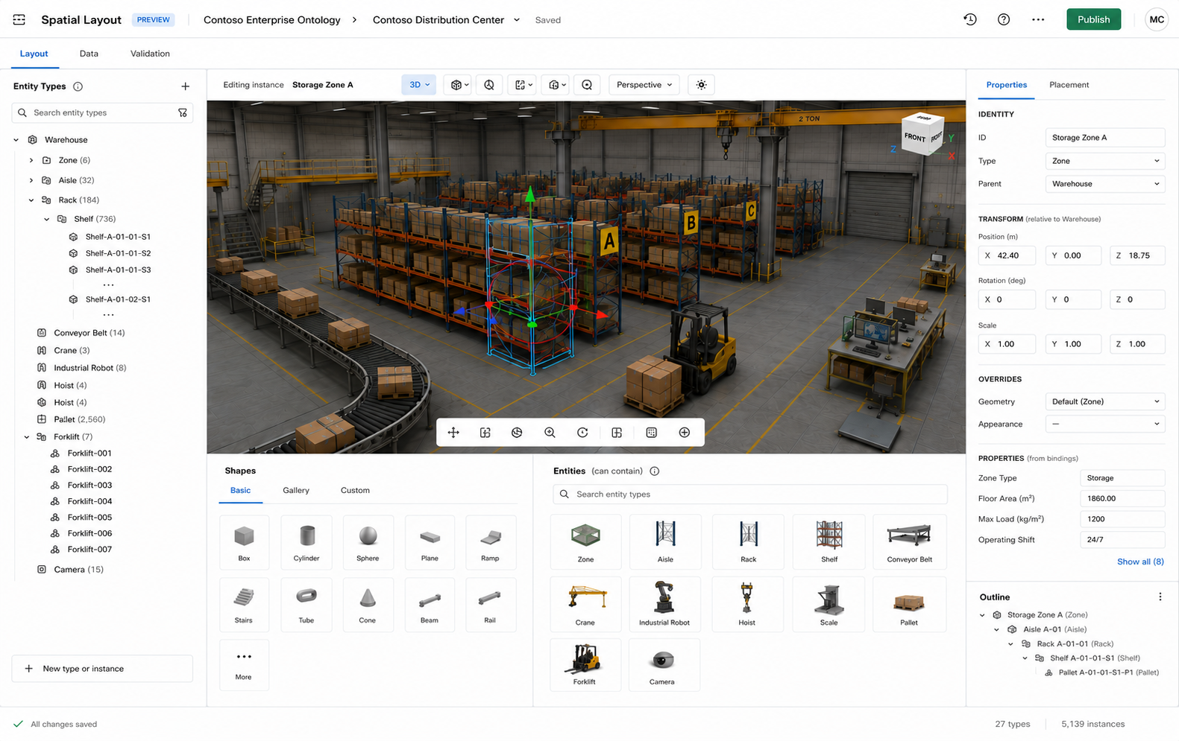
With a type selected, users author the type's default geometry by dropping and arranging shapes. Users can also promote an instance's geometry to become the type's default, replacing whatever was there. They also declare containment by creating a containment relationship type to another entity type, choosing an existing type or creating a new one. Placing child entity instances requires an instance to be selected, not a type. A contained type must have geometry before its instances can be placed, so any newly created contained type is given a default geometry before proceeding.
With an instance selected, users have everything available at the type level and more. They can drop shapes to override the instance's geometry and depart from the type default, or revert to the type default at any time. They can also place child entity instances from the Entities palette. To place one, users pick a type, then specify the instance by choosing an existing one from a data-backed list or entering a new ID. An ID that matches one in the enterprise's data lets that instance pick up live data and business context later through composition. Dropping it records its position and orientation relative to the parent. Moving assets are placed at a placeholder position, with their live position supplied later by the Ontology item and rendered by the Physical Space item.
Spatial Layout supports both 3D and 2D top-down views, since some customers care primarily about floor plan and 2D is often more practical for precise placement. Snapping places shapes and instances on the floor, against walls, or on a grid. Units are configurable and distances are measurable in the viewport. Multi-select, copy, even distribution, rotation, and mirroring support repetitive layouts such as rows of shelves or banks of equipment. Undo and redo apply to all actions. Named camera positions allow quick return to key views. Rendering is lightweight, optimized for layout clarity rather than visual fidelity. Spatial Layout is not a CAD tool: it covers the common case well, and customers who need precise geometry bring it in via USD, built using and exported from other tools.
The navigation pane, palettes, and viewport support keyboard navigation. Palette items, scene objects, and navigation pane entries carry screen-reader labels. UI chrome meets contrast requirements.
Fidelity grows on the customer's own timeline. Placeholders are replaced with higher-fidelity USD, more types and instances are added, and individual instances are overridden, all without breaking what already works. Saving the layout materializes the work into the underlying ontology, data, and USD assets, and an abandoned session writes nothing.

Decomposition
This is an advanced feature for customers who already have their environment as a single USD file, typically exported from CAD or BIM. Rather than building a layout from scratch, they import the file and decompose it into the entity types and instances that hand authoring would have produced. The result is the same ontology, data, and USD assets, and users continue with the normal tools from there.
This feature has practical scale limits: customers with very large or complex USD files are better served by a professional CAD or BIM tool that can export a conformant package directly, as described in the Ecosystem section.
The conceptual model is simple. Users select or create an entity instance (e.g., Warehouse 10) and import the USD file into it. The file loads with all geometry attributed to that instance. Decomposing means progressively re-attributing portions to child entity instances nested within it. By the end, every piece of geometry belongs to a specific entity instance, and Warehouse 10 retains only what remains: the walls, floor, and structure that do not represent a distinct tracked entity.
Users select portions of the geometry in the viewport and promote each selection to a child entity instance or to a type's default geometry. Promoting to an instance means picking or creating an entity type and assigning an ID, after which the selected geometry becomes that instance's USD asset and its position is expressed relative to its parent. Promoting to a type's default geometry is the efficient path for repeated assets: select one rack, define it as the Shelf type's default, then select all matching racks and assign them as Shelf instances sharing that geometry. Spatial Layout detects exact geometry matches automatically, but users can broaden the selection to include near-matches and minor variations.
The process works at any depth. After promoting zones from the warehouse, users select a zone and promote shelves from it. Each instance's position and orientation is stored relative to its direct parent, so the containment hierarchy is correctly nested regardless of depth.
If the source file has a named prim hierarchy, Spatial Layout surfaces it as a tree beside the 3D view with cross-highlighting, proposes named subtrees as instances, and pre-assigns names that match existing entity types. A flat or unlabeled file falls back to direct 3D selection.
Geometry not yet re-attributed stays with its nearest ancestor, so nothing is silently dropped. A running indicator shows how much geometry remains attributed to each ancestor.
The source USD file is never mutated. Spatial Layout extracts each promoted selection into its own USD asset and retains the remainder as the imported instance's geometry.

Sequencing
The MVP for Ignite 2026 delivers a self-contained spatial-focused ontology, its tables, and its USD assets, with a visual authoring experience for the common case. Reusing libraries, such as Babylon.js, would greatly accelerate the development. A staged build de-risks delivery, proving the core conceptual model first and adding value at each step.
- Core authoring: Navigation pane with create, edit, and delete for entity types and instances. Shapes palette with basic geometry (boxes, cylinders, planes) and Entities palette. Containment relationship type declaration. Instance placement by manual ID. Instance geometry override with revert to type default. Promote an instance's geometry to the type default. Interactive 3D viewport with camera controls (orbit, pan, zoom), drag-and-drop placement, scaling, transform handles, and live preview. Save and reload to/from JSON, CSV, and USD.
- Editing precision: Snapping to floor, walls, and grid. Units and distance measurement.
- Bulk operations and views: Multi-select, copy, distribution, rotation, and mirroring for repetitive layouts. 2D top-down view. Named camera positions. Undo and redo.
- USD import and asset library: Upload a USD asset or point to a OneLake folder of USD assets for use as entity geometry. Also, USD assets from the SimReady library are available in the Shapes palette.
- Decomposition: Re-attribute geometry to child instances and type defaults, with automatic geometry matching, a prim hierarchy tree with cross-highlighting, and depth-unlimited containment.
- Fabric item: Turn Spatial Layout into a first-class Fabric item that writes directly to a child Ontology item and a child Lakehouse item, whose tables hold the instance and containment data and whose files include the USD assets. Saving makes the result renderable in the Physical Space item.
- Ontology reference: Reference an existing Ontology item as a source of entity types and entity instance IDs, so users can browse and place instances already defined in the enterprise ontology rather than entering IDs manually.
- Quality, scale, and extensibility: Accessibility, robustness, performance tuning, scalability, and export.

Ecosystem
Spatial Layout addresses the 80% case: customers who build a layout from scratch using basic shapes and the SimReady library. The remaining 20% need high-fidelity environments, whether or not they already have them modeled, and that fidelity typically lives in CAD or BIM tools.
Fabric will publish a guide for ISVs and the community on how to produce conformant assets: geometry as USD, instance and containment data as CSV or Parquet, and the ontology as OWL/RDF or JSON. A conformant tool can write these files for import or create the child Ontology and Lakehouse items directly. Either way feeds the same pipeline as Spatial Layout.
The call to action for ISVs is to add export capabilities to CAD and BIM tools that decompose complex geometry into entity types, instances, containment relationships, and entity geometry. A plugin for a widely used tool removes the biggest friction point for high-fidelity customers: the gap between where their geometry lives and where the platform needs it.

